# **Area Frequency and Tie-Line Power Control of An Inter-Tied Power System Using – STATCOM**

**ABSTRACT**

Power system is said to be stable when generation is equal to the demand and unstable due to any uncertainties such as sudden change in load demand, fault conditions or any other disturbances; system frequency, voltage will cross its limits. If the system is operating with synchronism frequency is the main factor need to maintain within a permissible limit. This paper demonstrates the single area load frequency control and two-area load and tie line frequency control and tie-line power damping over the steady state value can be controlled by conventional integral controller which makes steady state error is zero, but it doesn’t show any impact on the transient behavior of the interconnected system with respect to load changes. FACTS (Flexible AC Transmission) devices like TCSC and STATCOM Can stimulate the tie-line power oscillations exquisitely under sudden occurrence of load changes in any of the area.

**Keywords: two area, tie-line, STATCOM, LFC, AGC**

# **1. INTRODUCTION**

The power system is said to be perfectly balanced, stable only when power generation is equal to the load demand. So, under system balanced criterion; system voltage, frequencies are at their normal operating levels. If load suddenly in- creases, system fault conditions, disturbances due to system switching, loss of generating unit, failure in the excitation system, failure in turbine governor causes system is to be unstable. If the system operating under unstable or unbalanced condition the system parameters may deviates from its boundaries causes loos in synchronize between control areas. So, we need to control the system parameters under disturbances. One of the main parameters is frequency which shows effect on the power system.

Modern power system network is widely distributed system with large number of generating stations and load centers. As the load demand on the system for electricity has been increasing day to day, several alternative means of energy productions by using renewable energy resources have gained at most importance. The interaction between generating stations and load demand centers has become very complex due to injection of renewable energy even at demand centers. Thus, the problem of load frequency control has become a critical issue in stability of the power system. Classical control schemes, though proving sufficient operation has several limitations like slow operation, improper tuning of parameters, parametric and non-parametric constraints, damping related issues.

For huge scale power systems involving various interconnected control areas, the main aim is to maintain the system frequency and the tie-line power within the permissible limits. For a similar advantage having by Automatic Generation Control (AGC) or Load Frequency Control (LFC) is very significant FACTS devices like static synchronous compensator is one of the basic devices used to reduce harmonics in interconnected power system. In general, these de- vices are shunt devices and are connected in parallel with the circuit to control the power system steady state stability and improves transient stability. STATCOM is one of the key controllers can be founded in two types. One is Voltage Source Controller (VSC) and other one is Current Source Controller (CSC). Fig. 5 Shows the single line diagram of the STATCOM. In economical aspect, VSC are mostly used. Main importance of VSC is its output AC voltage can be controlled and leads to reactive power control. A DC-link capacitor acts as voltage source and it delivers power as per the converter requirement. Like the active filters which absorbs harmonics in the system to retain system frequency. sometimes these STATCOM is also used for injection of current to maintain the system active powers within limits.

**1.1 Reasons for The Need of Maintaining Constant Frequency:**

1. The speed of a.c. motors are directly related to the frequency.
2. If the normal operating frequency is 50 Hz and the turbines run at speeds corresponding to frequencies less than 47.5 Hz or above 52.5 Hz, then the blades of the turbines may get damaged.
3. The operation of a transformer below the rated frequency is not desirable. When frequency goes below rated frequency at constant system voltage then the flux in the core increases and then the transformer core goes into the saturation region.
4. With reduced frequency the blast by ID fans and FD fans decreases, and so the generation decreases and thus it becomes a multiplying effect and may result in shut down of the plant.

# **2. LOAD FREQUENCY CONTROL**

LFC is considered as a one of the main important aspects in power system network as it considered as a direct representation for the primary constraint achievement in power system as well as a view for the change either in demand or generation side. The disturbance in load demand side in a certain area affects the frequency stability in the other areas so it is essential in the electric power networks to design such a load frequency controller to maintain the network stability.

Many researchers have been working to overcome the load frequency problems specially after increase the concept of multi area networks as several number of utilities are connected with each other through the tie lines which carries the power exchanged between them and the loss in stability appear in a certain area due to the influence of disturbance in the anther area, so it is necessary to design such a load frequency controller to enhance and maintain the frequency stability.

Many techniques has been carried on the design of LFC either; using the conventional PI controller which lead to bad results shown in large overshoots and dynamic performance due to the continuous variation of the operating point of power system or using the AI optimization techniques like Fuzzy logic, [Particle Swarm Optimization](https://www.sciencedirect.com/topics/engineering/particle-swarm-optimization) (PSO), Genetic Algorithm (GA) as it used in determining and tuning of the PID [controller parameters](https://www.sciencedirect.com/topics/engineering/controller-parameter) which enhance directly the system outputs. These control techniques are based on smooth computing for LFC parameters which guarantee not only the system frequency but also zero elimination [Steady state error](https://www.sciencedirect.com/topics/engineering/steady-state-error).

The research field in multi area power system was carried out in previous articles , shows the enhancement of using fuzzy logic for PI controller in dynamic performance when compared with the conventional PI controller, while Presents the implementation of both fuzzy logic and [Particle Swarm](https://www.sciencedirect.com/topics/engineering/particle-swarm) for optimization of PID [controller gains](https://www.sciencedirect.com/topics/engineering/controller-gain) used in five area LFC.

Presents the implementation of ANN and fuzzy logic for enhancement the performance of PID used in four area such that area 1 and area 2 consists of thermal reheat power plant and the area 3 and area 4 consists if [hydro power](https://www.sciencedirect.com/topics/engineering/hydro-power) plant. Reference no Presents the tuning of PID controller used in LFC in four area networks using fire fly algorithm. The LFC was presented with the penetration of wind generation in hydro power plant integrated with a thermal power plant in supplying a load. Gives a wide view for different control techniques and different power resources used as well as the values of overshoots and settling time for different operating conditions Presents a frequency control scheme for an isolated power system consists of hydro power plant, diesel generator, photo voltaic and fuel cell and the enhancement in the dynamic system performance using different techniques. Ziegler and Nichols were proposed PID [controller tuning](https://www.sciencedirect.com/topics/engineering/controller-tuning) methods in 1942 and have been widely utilized either in the original form or in modified forms. Different types of PID controller tuning methods were discussed in Ziegler and Nichols method is considered as a base case for comparison the settling times, overshoots and maximum deviation In the past few years [MPC](https://www.sciencedirect.com/topics/engineering/predictive-control-model) are used in power system applications as a powerful tool and shows great improvement in the stability performance, Model predictive control (MPC) is considered as a one of the most recent promising control algorithms that utilize an explicit process model to predict the future response of plant The PID controller was commonly used in electrical power system applications while the Fraction Order PID is now widely used as an alternative for the PID based on AI optimization techniques, in order to achieve the optimum design of controller through taking into account five different design specifications instead of three parameters which adds more flexibility to [controller design](https://www.sciencedirect.com/topics/engineering/controller-design) and real world processes become more accurately controlled The applications of using fuzzy logic for load frequency control was indicated. FOPID controller are now widely used for different applications instead of the conventional PID controller.

This work is considered as a development in the work done but with the modifying of the four area system to be interconnected with [renewable resources](https://www.sciencedirect.com/topics/engineering/renewable-energy-resource) as [wind turbine](https://www.sciencedirect.com/topics/engineering/wind-turbines) and [photo voltaic system](https://www.sciencedirect.com/topics/engineering/photovoltaic-system) as well as the designed controller is designed to be based on FOPID and MPC. The effect of electric vehicle charging, and discharging is also considered in the proposed model. The comparison is done in this article through specified methods of tuning. The conventional PID controller may give better response using another adaptation technique. But we are succeeding to improve the frequency deviation response of 4 area using FOPID and MPC.

Figure.1 shows Generic load frequency control mechanism. Change in load, make variations in electrical torque of the generator, and this variation results in a mismatch between the mechanical and electrical torque, resulting in speed variations. The governor will sense the variation in speed and adjust the valve position to increase /decrease steam flow from the furnace toward the turbine to balance the torque mismatch (primary loop). This balance is rarely performed at the rated frequency. Therefore, “to achieve the rated frequency of the system and recompense for power imbalance”, the governor’s set point is changed by the actions of an automatic load frequency control controller whose decisions are taken promptly and have to offer strong power system operation under several different contingency situations.

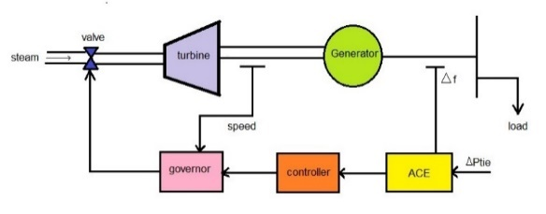

**Figure 2.1. Generic load frequency scheme**

##### **2.1 Load Frequency Problems:**

If the system is connected to numerous loads in a power system, then the system frequency and speed change with the characteristics of the governor as the load changes. If it’s not required to maintain the frequency constant in a system, then the operator is not required to change the setting of the generator. But if constant frequency is required the operator can adjust the velocity of the turbine by changing the characteristics of the governor when required. If a change in load is taken care by two generating stations running parallel, then the complex nature of the system increases. The ways of sharing the load by two machines are as follow:

1. Suppose there are two generating stations that are connected to each other by tie line. If the change in load is either at A or at B and the generation of A is regulated to have constant frequency, then this kind of regulation is called as Flat Frequency Regulation.
2. The other way of sharing the load is that both A and B would regulate their generations to maintain the frequency constant. This is called parallel frequency regulation.
3. The third possibility is that the change in the frequency of a particular area is taken care of by the generator of that area thereby maintain the tie-line loading. This method is known as flat tie- line loading control.
4. In Selective Frequency control each system in a group is taken care of the load changes on its own system and does not help the other systems, the group for changes outside its own limits.
5. In Tie-line Load-bias control all the power systems in the interconnection aid in regulating frequency regardless of where the frequency change originates.

##### **2.2 Load Frequency Control Using Pole-Placement Design:**

PL = 0.2;

A = [-5 0 -100; 2 -2 0; 0 0.1 -0.08];

B = [0; 0; -0.1]; BPL = B\*PL;

C = [0 0 1]; D = 0;

t=0:0.02:10;

[y, x] = step(A, BPL, C, D, 1, t);

figure(1), plot(t, y), grid

xlabel('t, sec'), ylabel('pu')

r =eig(A)

Uncompensated frequency deviation step response Settling time of the uncompensated system is 4seconds.Now we are interested to find k such that the roots of the characteristic equation is at -2+j6,- 2-j6 and -3.

Following commands is required to find the desired output: P=[-2.0+j\*6 -2.0-j\*6 -3];

[K, Af] = placepol(A, B, C, P); t=0:0.02:4;

[y, x] = step(Af, BPL, C, D, 1, t);

figure(2), plot(t, y), grid xlabel('t, sec'), ylabel('pu')

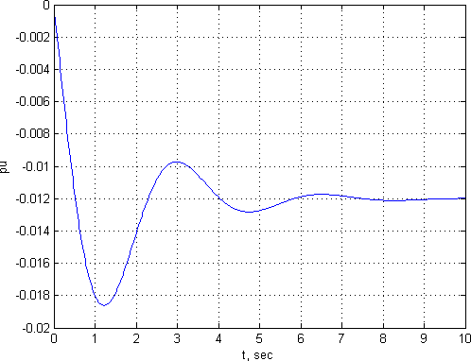

**Fig 2.2:- Uncompensated frequency deviation step response Settling time of the uncompensated system is 4seconds.**

Now we are interested to find k such that the roots of the characteristic equation is at -2+j6,- 2-j6 and -3.

Following commands is required to find the desired output: P=[-2.0+j\*6 -2.0-j\*6 -3];

[K, Af] = placepol(A, B, C, P); t=0:0.02:4;

[y, x] = step(Af, BPL, C, D, 1, t);

figure(2), plot(t, y), grid xlabel('t, sec'), ylabel('pu')

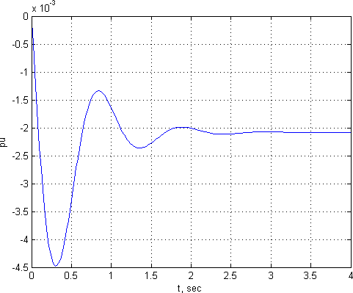

**Fig 2.3 Compensated Frequency deviation step response**

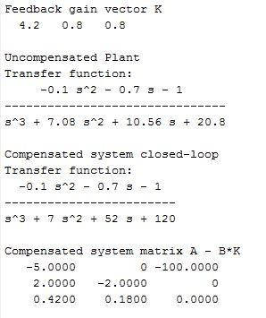

The result of the above-mentioned MATLAB code is:

**Fig 2.4: Output of the pole placement technique**

Thus, the state feedback constants k1= 4.2, k2= 0.8 and k3= 0.8 results in the desired characteristic equation roots. We have seen transient response has improved and the response settles to a steady state value of -.0017 p.u.in 2.5 seconds.

##### **2.3 Load Frequency Control Using Optimal Control Design:**

Performance index is given as:

J=∫ ∞(20𝑥2 + 15𝑥2 + 5𝑥2 + 0.15𝑢2)

0 1 2 3

MATLAB CODE:

PL=0.2;

A = [-5 0 -100; 2 -2 0; 0 0.1 -0.08];

B = [0; 0; -0.1]; BPL=PL\*B;

C = [0 0 1];

D = 0;

Q = [20 0 0; 0 10 0; 0 0 5];

R = .15;

[K, P] = lqr2(A, B, Q, R) Af = A - B\*K t=0:0.02:1;

[y, x] = step(Af, BPL, C, D, 1, t);

plot(t, y), grid

xlabel('t, sec'), ylabel('pu')

The output is:

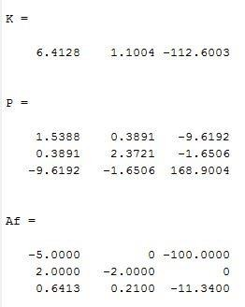

**Fig 2.5: Output of the LFC using optimal control design**

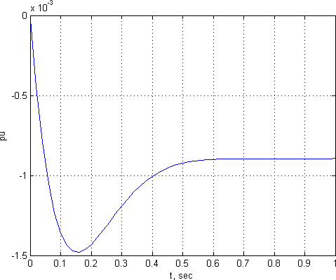

**Fig 2.6 Frequency deviation step response of LFC using optimal control design**

We see that the transient response settles to a steady state of -0.0007 pu in about 0.6seconds.

# **3. SINGLE-AREA LOAD FREQUENCY CONTROL**

Single control area is nothing but area in which all the generators are closely coupled together, synchronized to control the output power of all the generators to maintain the scheduled frequency of the system within a permissible limit. In such an electric area all the generators whose speeds increasing and decreasing simultaneously such coherent area can be called as control area. During in both dynamic and static conditions the frequency response is same.

A single control area consisting of turbine, governor, electric generators whose transfer functions are indicated in block diagram as shown in Figure.2, where K*i* is the integral controller gain constant, K*g*, K*t*, K*p* are the governor, turbine, generator gain constants, And T*g*, T*t*, T*p* the governor, turbine, generator time constants. And ∆P*d* is the deviation in load demand ∆f be the change in area Frequency with respect to load change.

**Figure 3.1. single area load frequency control block diagram**

**Load frequency control – single area** Figure.3.1 indicates the frequency response of the single area load - frequency control. the steady state frequency deviations due to change in two parameters one is change in load other one is change in speed changer setting. In this the main objective of the speed changer setting is to bring the steady state system frequency to the scheduled frequency by adjusting itself when the system subjected to unacceptable dynamic system frequency deviations. When there is a sudden change in load then speed changer setting can be automatically adjusted by observing the changes is frequency. A signal ∆F can be feedback to input through integrator to the speed changer. Now the system can be modified into proportional plus integral controller which gives steady state error to be zero.

**Figure 3.2 Single control area load frequency response**

All the individual blocks can now be connected to represent the complete ALFC loop as

## Power Generation

 We have

∆PG(s) =  kGkt / (1+sTG)(1+sTt)[∆Pc(s)-1/R∆F(s)]

 The generator is synchronized to a network of very large size. So, the speed or frequency will be essentially independent of any changes in a power output of the generator

ie, ∆F(s) =0

Therefore ∆PG(s) =kGkt / (1+sTg) (1+sTt)\* ∆Pc(s)

Steady state response

### (i)Controlled case:

To find the resulting steady change in the generator output:

Let us assume that we made a step change of the magnitude ∆Pc of the speed changer For step change, ∆Pc(s) = ∆Pc/s

∆PG(s) =kGkt/ (1+sTg) (1+sTt). ∆Pc(s)/s s∆PG (s) =kGkt/ (1+sTg) (1+sTt). ∆Pc(s)

  Applying final value theorem,

  ∆PG (stat) = ∆

 (ii)Uncontrolled case

Let us assume that the load suddenly increases by small amount ∆PD.

Consider there is no external work and the generator is delivering a power to a single load.

  ∆Pc = 0

  Kg Kt = 1

  ∆PG(s) = 1/ (1+sTG) (1+sTt) [-∆F(s)/R]

  For a step change ∆F(s) = ∆f/s

  Therefore

  ∆PG(s) = 1/(1+sTG)(1+sTt)[-∆F/sR]

  ∆f/∆PG (stat) =-R Hz/MW

**Steady State Performance of the ALFC Loop**

 In the steady state, the ALFC is in „open‟ state, and the output is obtained by substituting s→0 in the TF.

 With s→0, Gg(s) and Gt(s) become unity, then, (note that

 ∆Pm =∆PT = PG =∆Pe = ∆PD;

 That is turbine output = generator/electrical output = load demand)

 ∆Pm  = ∆Pref – (1/R) ∆ω or ∆Pm  = ∆Pref – (1/R)∆f

When the generator is connected to infinite bus (∆f = 0, and ∆V = 0), then

∆ Pm = ∆Pref . If the network is finite, for a fixed speed changer setting (∆Pref = 0), then

∆Pm  =   (1/R)∆f or ∆f=RPm.

## **Concept of AGC (Supplementary ALFC Loop)**

* It achieves the primary goal of real power balance by adjusting the turbine output ∆Pm to match the change in load demand ∆PD.
* All the participating generating units contribute to the change in generation. But a change in load results in a steady state frequency deviation ∆f.
* The restoration of the frequency to the nominal value requires an additional control loop called the supplementary loop.
* This objective is met by using integral controller which makes the frequency deviation zero.
* The ALFC with the supplementary loop is generally called the AGC. The block diagram of an AGC is shown in Fig.
* the main objectives of AGC are

1. To regulate the frequency (using both primary and supplementary controls);
2. And to maintain the scheduled tie-line flows.

 A secondary objective of the AGC is to distribute the required change in generation among the connected generating units economically (to obtain least operating costs).

## **AGC in a Single Area System**

¬ In a single area system, there is no tie-line schedule to be maintained.

¬ Thus, the function of the AGC is only to bring the frequency to the nominal value.

¬ This will be achieved using the supplementary loop (as shown in Fig.) which uses the integral controller to change the reference power setting so as to change the speed set point.

¬ The integral controller gain KI needs to be adjusted for satisfactory response (in terms of overshoot, settling time) of the system.

¬ Although each generator will be having a separate speed governor, all the generators in the control area are replaced by a single equivalent generator, and the ALFC for the area corresponds to this equivalent generator.

A number of control areas are when interconnected forms a large power system. In case of two, single control areas are inter-tied there may be deviation in the entire system frequency need to be control knows as two area load frequency control and, are inter-tied by line called tie-line whose frequency, tie line power are need to be constant under normal operating conditions. If any one of area load changes suddenly, entire power system frequency and tie line power also changes. Fig.4 shows interconnected system block diagram.

**Figure 3.5. Single line diagram of interconnected system**

# FORMULATION

From Area 1, to Area 2 change in tie line power

🡪(1)

From Area 2, to Area 1 change in tie line power

🡪(2)

Two Area Load Frequency Control – An extended power system can be divided into a number of Two Area Load Frequency Control areas interconnected by means of tie lines. Without loss of generality we shall consider a two-area case connected by a single tie line as illustrated in Fig. 8.13.

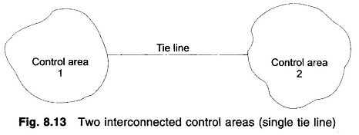

The control objective now is to regulate the frequency of each area and to simultaneously regulate the tie line power as per inter-area power contracts. As in the case of frequency, proportional plus integral controller will be installed so as to give zero steady state error in tie line power flow as compared to the contracted power.

It is conveniently assumed that each control area can be represented by an equivalent turbine, generator and governor system. Symbols used with suffix 1 refer to area 1 and those with suffix 2 refer to area 2.

In an isolated control area case, the incremental power (ΔPG– ΔPD) was accounted for by the rate of increase of stored kinetic energy and increase in area load caused by increase in [frequency](http://www.circuitstoday.com/). Since a tie line transports power in or out of an area, this fact must be accounted for in the incremental power balance equation of each area.

Power transported out of area 1 is given by

Two Area Load Frequency Control

were

δ01,δ02 = power angles of equivalent machines of the two areas.

For incremental changes in δ1 and δ2, the incremental tie line power can be expressed as

Two Area Load Frequency Control

Were



Since incremental power angles are integrals of incremental frequencies, we can write Eq. (8.27) as

Two Area Load Frequency Control

where Δf1 and Δf2 are incremental frequency changes of areas 1 and 2, respectively.

Similarly, the incremental tie line power out of area 2 is given by

Two Area Load Frequency Control

Were



With reference to earlier equation, the incremental power balance equation for area 1 can be written as

Two Area Load Frequency Control

It may be noted that all quantities other than frequency are in per unit in Eq. (8.31).

Taking the Laplace transform of Eq. (8.31) and reorganizing, we get

Two Area Load Frequency Control

whereas defined earlier



Compared to earlier equation of the isolated control area case, the only change is the appearance of the signal ΔPtie,1(s) as shown in Fig. 8.14.

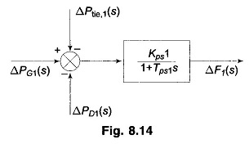

Taking the Laplace transform of Eq. (8.28), the signal ΔPtie,1(s) is obtained as

Two Area Load Frequency Control

The corresponding block diagram is shown in Fig. 8.15.

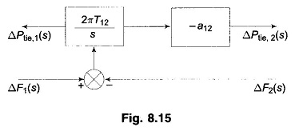

For the control area 2, ΔPtie,2(s) is given by [Eq. (8.29)]

Two Area Load Frequency Control

which is also indicated by the block diagram of Fig.

Let us now turn our attention to ACE (area control error) in the presence of a tie line. In the case of an isolated control area, ACE is the change in area frequency which when used in integral control loop forced the steady state frequency error to zero. In order that the steady state tie line power error in a two-area control be made zero another integral [control loop](https://www.eeeonline.org/) (one for each area) must be introduced to integrate the incremental tie line power signal and feed it back to the speed changer. This is accomplished by a single integrating block by redefining ACE as a linear combination of incremental frequency and tie line power. Thus, for control area 1.



where the constant b1 is called area **frequency bias**.

Equation (8.36) can be expressed in the Laplace transform as

Two Area Load Frequency Control

Similarly, for the control are a 2, ACE2 is expressed as



Combining the basic block diagrams of the two control areas, with ΔPC1(s) and ΔPC2(s) generated by integrals of respective ACEs (obtained through signals representing changes in tie line power and local frequency bias) and employing the block diagrams of Figs. 8.14 to 8.15, we easily obtain the composite block diagram

Let the step changes in loads ΔPD1 and ΔPD2 be simultaneously applied in control areas 1 and 2, respectively. When steady conditions are reached, the output signals of all integrating blocks will become constant and in order for this to be so, their input signals must become zero. We have, therefore

From Eqs. (8.28) and (8.29)

Two Area Load Frequency Control

Hence Eqs. (8.39) — (8.41) are simultaneously satisfied only for

Two Area Load Frequency Control

and



Thus, under steady condition change in the tie line power and frequency of each area is zero. This has been achieved by integration of ACEs in the feedback loops of each area.

Dynamic response is difficult to obtain by the [transfer function](https://www.eeeonline.org/) approach (as used in the single area case) because of the complexity of blocks and multi-input (ΔPD1, ΔPD2) and multi-output (ΔPtie,1,ΔPtie,2,Δf1, Δf2) situation. A more organized and more conveniently carried out analysis is through the state space approach (a time domain approach). Formulation of the state space model for the two-area system.

The results of the two-area system (ΔPtie, change in tie line power and Δf, change in frequency) obtained through digital computer study are shown in the form of a dotted line. The Two Area Load Frequency Control are assumed to be identical with system parameters given by

Two Area Load Frequency Control

A **proportional-integral-derivative controller** (**PID controller**) is a control loop feedback mechanism (controller) widely used in industrial control systems. A PID controller calculates an *error* value as the difference between a measured process variable and a desired setpoint. The controller attempts to minimize the *error* by adjusting the process through use of a manipulated variable.

The PID controller algorithm involves three separate constant parameters, and is accordingly sometimes called **three-term control**: the proportional, the integral and derivative values, denoted *P, I,* and *D.* Simply put, these values can be interpreted in terms of time: ***P* depends on the *present* error, *I* on the accumulation of *past* errors, and *D* is a prediction of *future* errors**, based on current rate of change. The weighted sum of these three actions is used to adjust the process via a control element such as the position of a control valve, a damper, or the power supplied to a heating element.

**4. PID CONTROLLER**

In the absence of knowledge of the underlying process, a PID controller has historically been considered to be the most useful controller. By tuning the three parameters in the PID controller algorithm, the controller can provide control action designed for specific process requirements. The response of the controller can be described in terms of the responsiveness of the controller to an error, the degree to which the controller overshoots the setpoint, and the degree of system oscillation. Note that the use of the PID algorithm for control does not guarantee optimal control of the system or system stability.

Some applications may require using only one or two actions to provide the appropriate system control. This is achieved by setting the other parameters to zero. A PID controller will be called a PI, PD, P or I controller in the absence of the respective control actions. PI controllers are fairly common, since derivative action is sensitive to measurement noise, whereas the absence of an integral term may prevent the system from reaching its target value due to the control action.

**4.1 PID Controller Theory**

The PID control scheme is named after its three correcting terms, whose sum constitutes the manipulated variable (MV). The proportional, integral, and derivative terms are summed to calculate the output of the PID controller.

1. **Interactive Algorithm**

1 𝑡 𝑑

𝑢(𝑡) = 𝐾𝑐 [𝑒(𝑡) + 𝑇𝑖 ∫ 𝑒(𝑟)𝑑𝑟] × [1 + 𝑇𝑑 𝑑𝑡 𝑒(𝑡)]

0

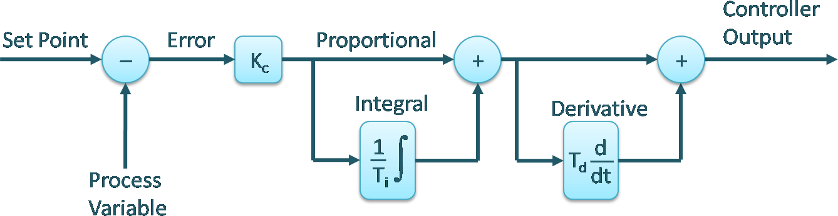

**Figure 4.1: Interactive Algorithm**

1. **Non-Interactive Algorithm**

## 1 𝑡 𝑑

𝑢(𝑡) = 𝐾𝑐 [𝑒(𝑡) + 𝑇𝑖 ∫ 𝑒(𝑟)𝑑𝑟 + 𝑇𝑑 𝑑𝑡 𝑒(𝑡)]

0

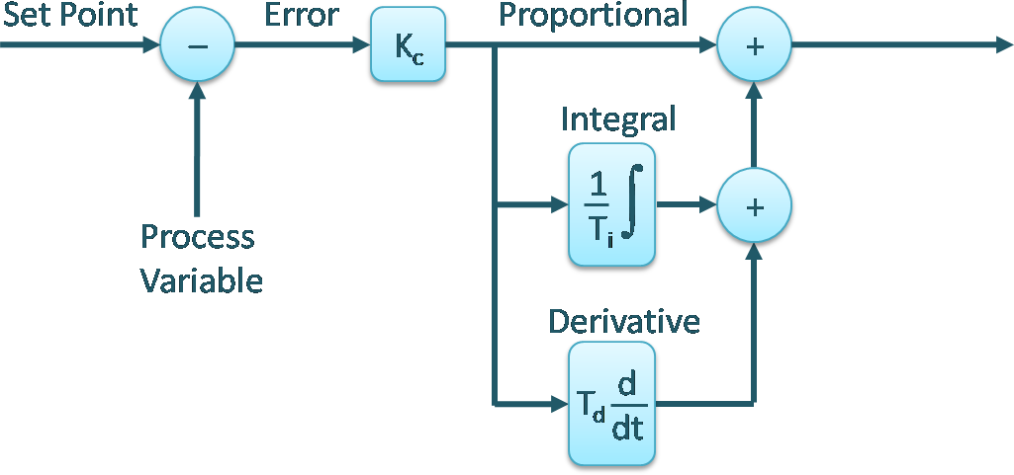

**Figure 4.2: Noninteractive Algorithm**

1. **Parallel Algorithm**

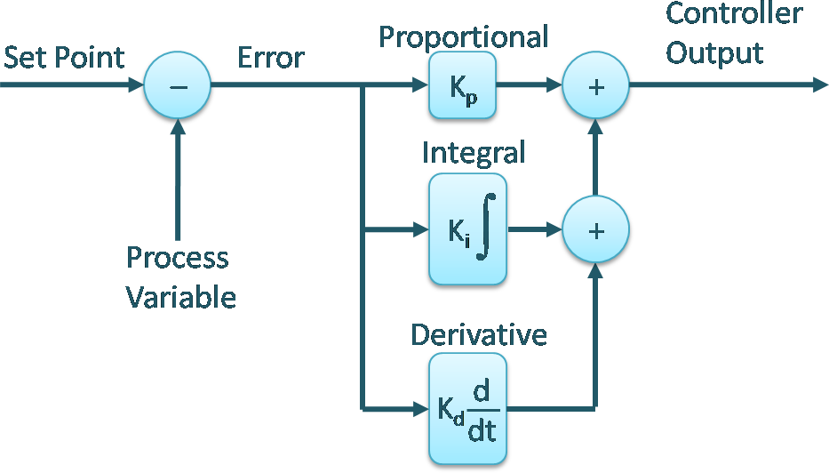|

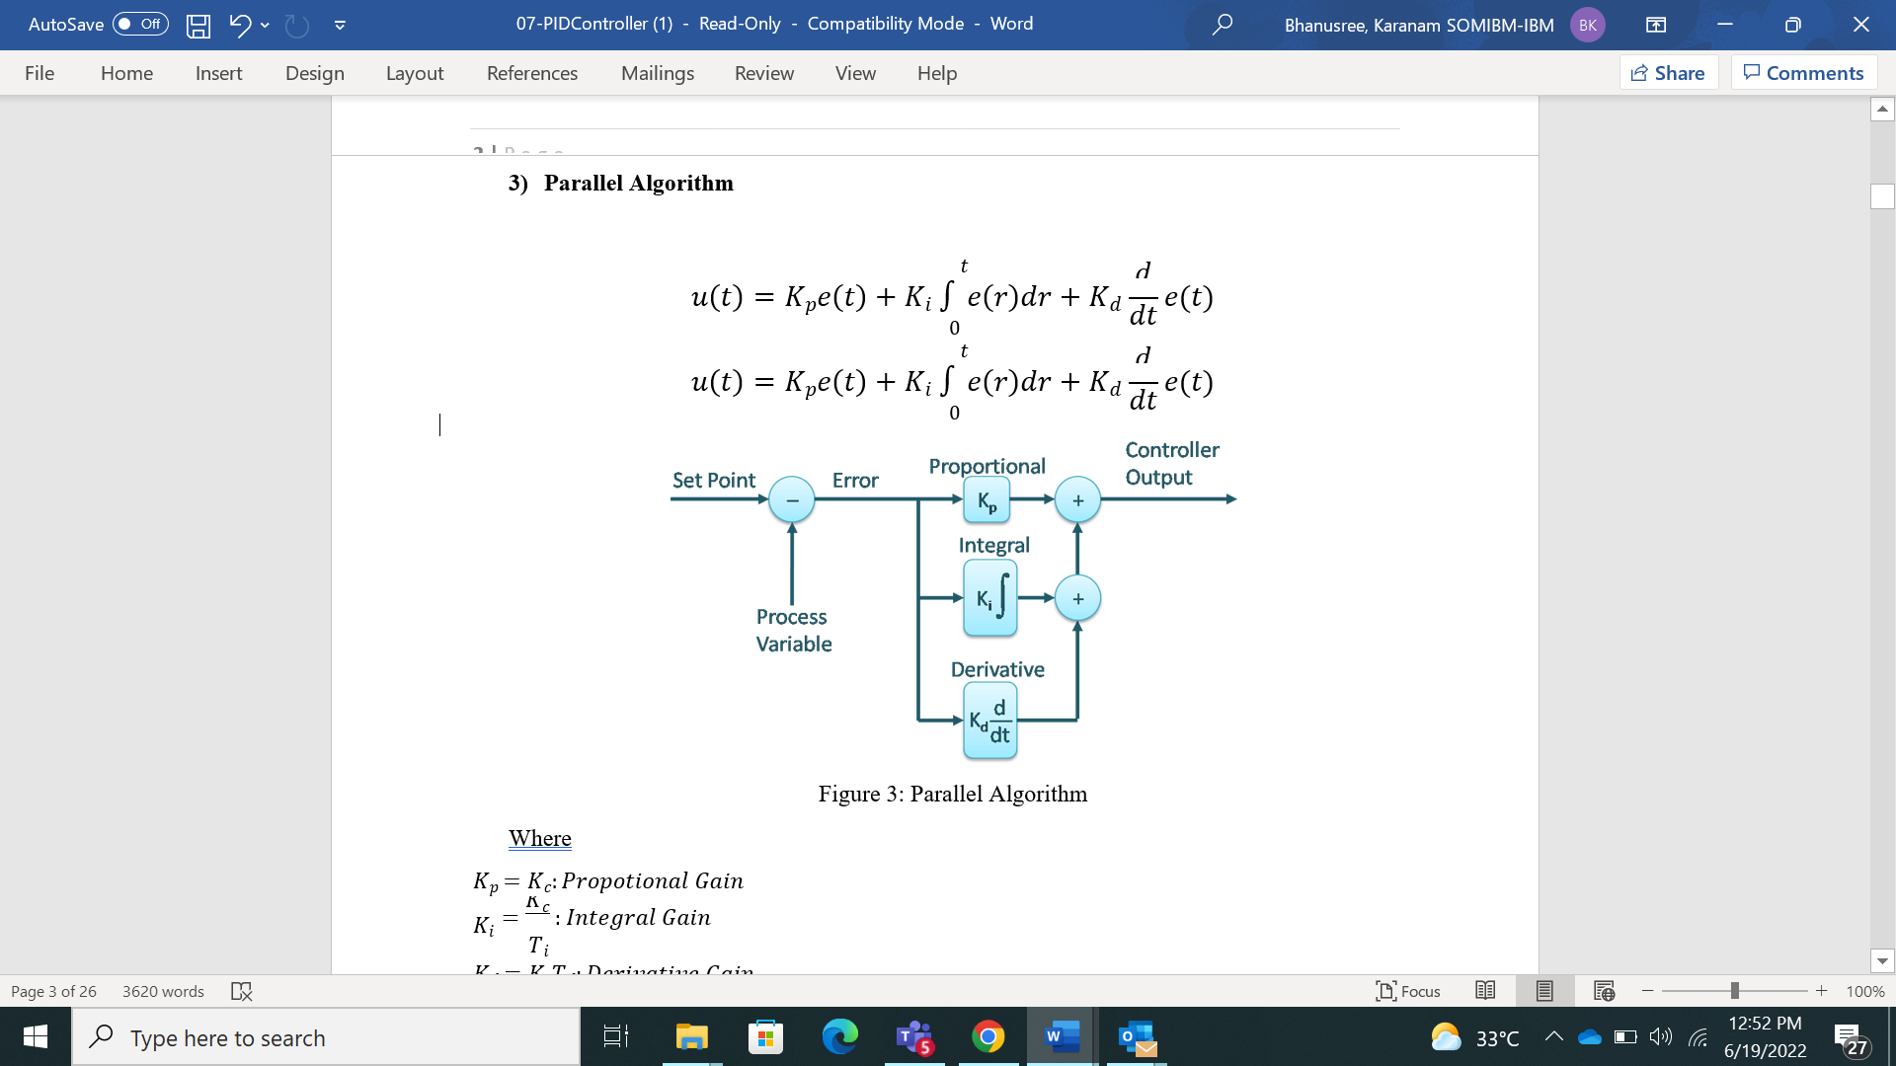

Were

𝐾𝑝 = 𝐾𝑐: 𝑃𝑟𝑜𝑝𝑜𝑡𝑖𝑜𝑛𝑎𝑙 𝐺𝑎𝑖𝑛

**Figure 4.3: Parallel Algorithm**

𝐾𝑖

= 𝐾𝑐 : 𝐼𝑛𝑡𝑒𝑔𝑟𝑎𝑙 𝐺𝑎𝑖𝑛

𝐾𝑑 = 𝐾𝑐𝑇𝑑: 𝐷𝑒𝑟𝑖𝑣𝑎𝑡𝑖𝑣𝑒 𝐺𝑎𝑖𝑛

𝑒(𝑡) = 𝑟(𝑡) − 𝑦(𝑡)

𝑇𝑖

**Proportional Term**

The proportional term produces an output value that is proportional to the current error value. The proportional response can be adjusted by multiplying the error by a constant Kp, called the proportional gain constant. The proportional term is given by:

𝑃𝑜𝑢𝑡 = 𝐾𝑝𝑒(𝑡)

A high proportional gain results in a large change in the output for a given change in the error. If the proportional gain is too high, the system can become unstable. In contrast, a small gain results in a small output response to a large input error, and a less responsive or less sensitive controller. If the proportional gain is too low, the control action may be too small when responding to system disturbances. Tuning theory and industrial practice indicate that the proportional term should contribute the bulk of the output change

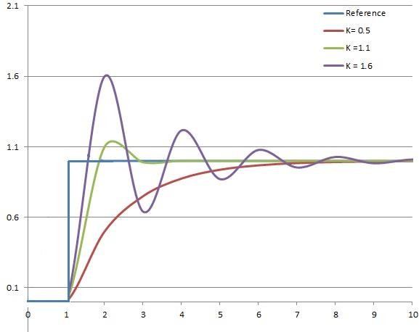

**Figure 4.4: The effect of add 𝐾𝑝 (𝐾𝑖, 𝑎𝑛𝑑 𝐾𝑑) held constant**

**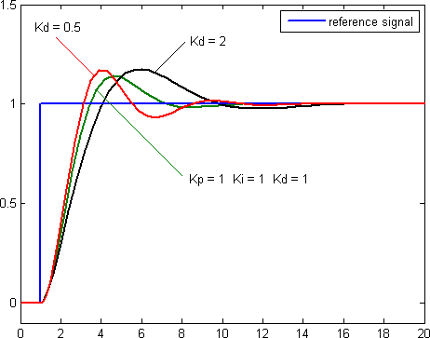Derivative Term**

The [derivative](http://en.wikipedia.org/wiki/Derivative) of the process error is calculated by determining the slope of the error over time and multiplying this rate of change by the derivative gain 𝐾d. The magnitude of the contribution of the derivative term to the overall control action is termed the derivative gain, 𝐾d. The derivative term is given by

## 𝑑

𝐷𝑜𝑢𝑡 = 𝐾𝑑 𝑑𝑡 𝑒(𝑡)

Above Figure 4.5: The effect of add 𝐾i (𝐾p, 𝑎𝑛𝑑 𝐾d) held constant Derivative action predicts system behavior and thus improves settling time and stability of the system. An ideal derivative is not [causal](http://en.wikipedia.org/wiki/Causal_system), so that implementations of PID controllers include an additional low pass filtering for the derivative term, to limit the high frequency gain and noise. Derivative action is seldom used in practice though - by one estimate in only 20% of deployed controllers- because of its variable impact on system stability in real-world applications.

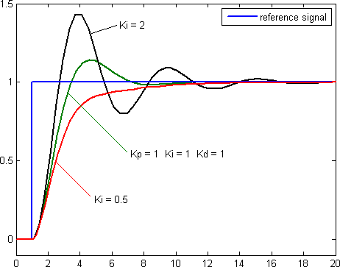

**Figure 4.6 The effect of add 𝐾d (𝐾p, 𝑎𝑛𝑑 𝐾i) held constant**

Table 1: Effect of increasing parameter independently

|  |  |  |  |  |  |
| --- | --- | --- | --- | --- | --- |
| **Parameter** | **Rise Time** | **Overshoot** | **Settling Time** | **Steady-State Error** | **Stability** |
| 𝑲𝒑 | Decrease | Increase | Small Change | Decrease | Degrade |
| 𝑲𝒊 | Decrease | Increase | Increase | Eliminate | Degrade |
| 𝑲𝒅 | Minor Change | Decrease | Decrease | No Effect | Improve if  𝐾𝑑 small |

Increasing the proportional gain ($K_p$) has the effect of proportionally increasing the control signal for the same level of error. The fact that the controller will "push" harder for a given level of error tends to cause the closed-loop system to react more quickly, but also to overshoot more. Another effect of increasing $K_p$ is that it tends to reduce, but not eliminate, the **steady-state error**.

The addition of a derivative term to the controller ($K_d$) adds the ability of the controller to "anticipate" error. With simple proportional control, if $K_p$ is fixed, the only way that the control will increase is if the error increases. With derivative control, the control signal can become large if the error begins sloping upward, even while the magnitude of the error is still relatively small. This anticipation tends to add damping to the system, thereby decreasing overshoot. The addition of a derivative term, however, has no effect on the steady-state error.

The addition of an integral term to the controller ($K_i$) tends to help reduce steady-state error. If there is a persistent, steady error, the integrator builds and builds, thereby increasing the control signal and driving the error down. A drawback of the integral term, however, is that it can make the system more sluggish (and oscillatory) since when the error signal changes sign, it may take a while for the integrator to "unwind."

The general effects of each controller parameter ($K_p$, $K_d$, $K_i$) on a closed-loop system are summarized in the table below. Note, these guidelines hold in many cases, but not all. If you truly want to know the effect of tuning the individual gains, you will have to do more analysis, or will have to perform testing on the actual system.

**4.2 Overview of Methods**

There are several methods for tuning a PID loop. The most effective methods generally involve the development of some form of process model, then choosing P, I, and D based on the dynamic model parameters. Manual tuning methods can be relatively inefficient, particularly if the loops have response times on the order of minutes or longer.

The choice of method will depend largely on whether or not the loop can be taken "offline" for tuning, and on the response time of the system. If the system can be taken offline, the best tuning method often involves subjecting the system to a step change in input, measuring the output as a function of time, and using this response to determine the control parameter

Where are PID controllers used?

[[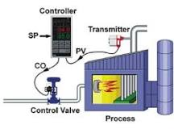](https://www.google.com/search?q=Where+are+PID+controllers+used?&tbm=isch&source=iu&ictx=1&vet=1&fir=rd2YvInhmJUlFM%252CI_N5OpDmuh1xMM%252C%252Fm%252F0hjcv&usg=AI4_-kRhPyNTAk-VkAqqxwnCZsPf7f6zEQ&sa=X&ved=2ahUKEwjA0ara8rj4AhWQS2wGHWpGCmgQ9QF6BAgsEAE#imgrc=rd2YvInhmJUlFM)](https://www.google.com/search?q=Where+are+PID+controllers+used?&tbm=isch&source=iu&ictx=1&vet=1&fir=rd2YvInhmJUlFM%252CI_N5OpDmuh1xMM%252C%252Fm%252F0hjcv&usg=AI4_-kRhPyNTAk-VkAqqxwnCZsPf7f6zEQ&sa=X&ved=2ahUKEwjA0ara8rj4AhWQS2wGHWpGCmgQ9QF6BAgsEAE" \l "imgrc=rd2YvInhmJUlFM)

**4.3 Open Loop Method**

In these methods, the PID is being tuned in open loop, isolated from the process plant. First a step input is applied to the plant and the process reaction curve is obtained. Using the process reaction curve with one of the First Order Plus Dead Time (FOPDT) estimation methods an approximation of the process is calculated. Knowing 𝐾𝑚, 𝑟𝑚 and 𝑡𝑑 the PID parameters can be evaluated from the related correlations according to the method used.

First Order Plus Dead Time (FOPDT) is given by

𝐺(𝑠) = 𝐾𝑚 𝑒−𝑡𝑑𝑠

𝑟𝑚𝑠 + 1

### **4.4 Ziegler-Nichols Open Loop Method**

In the 1940's, Ziegler and Nichols devised two empirical methods for obtaining controller parameters. Their methods were used for first order plus dead time situations, and involved intense manual calculations. With improved optimization software, most manual methods such as these are no longer used. However, even with computer aids, the following two methods are still employed today, and are considered among the most common.

This method remains a popular technique for tuning controllers that use proportional, integral, and derivative actions. The Ziegler-Nichols open-loop method is also referred to as S-shaped curve method, because it tests the open-loop reaction of the process to a change in the control variable output. This basic test requires that the response of the system be recorded, preferably by a plotter or computer. Once certain process response values are found, they can be plugged into the Ziegler- Nichols equation with specific multiplier constants for the gains of a controller with either P, PI, or PID actions.

In this method, we obtain experimentally the open loop response of the FOPDT to a unit step input. This method only applied if the response to a step input exhibits an *s*-shaped curve as shown in figure. This means that if the plant involves integrators (like 2nd order prototypes system) or complex-conjugate poles (general 2nd order system), then this method can’t be applied since *s*- shaped will not be obtained.

This method remains a popular technique for tuning controllers that use proportional, integral, and derivative actions. The Ziegler-Nichols open-loop method is also referred to as a process reaction method, because it tests the open-loop reaction of the process to a change in the control variable output.

#### **4.4.1 The Tuning Procedure:**

To use the Ziegler-Nichols open-loop tuning method, you must perform the following steps:

1. Make an open loop step test
2. From the [process reaction curve](http://controls.engin.umich.edu/wiki/index.php/PIDTuningClassical#Process_Reaction_Curve) determine the transportation lag or dead time, 𝑡𝑑, the time constant or time for the response to change, 𝑟𝑚, and the ultimate value that the

response reaches at steady-state, 𝐾𝑚, for a step change of 𝑋𝑜 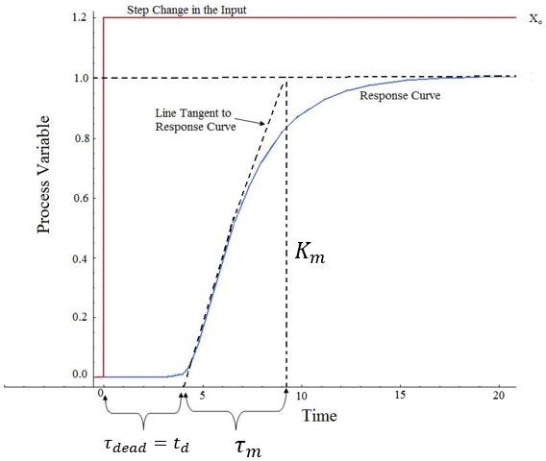

**Figure 4.7: Open Loop of First order system plus dead Time (s-shaped curve)**

The PID controller tuned by this method gives (according to the formula shown in Table.



**4.4.2 Advantages Ziegler-Nichols Open Loop Tuning Methods**

1. Quick and easier to use than other methods
2. It is a robust and popular method

**4.4.3 Disadvantages Ziegler-Nichols Open Loop Tuning Methods**

1. It depends upon purely 𝑡𝑑to estimate I and D controllers.

Approximations for the 𝐾𝑝. 𝑇𝑖, and 𝑇𝑑 values might not be entirely accurate for different systems.

1. It does not hold for I, D and PD controllers

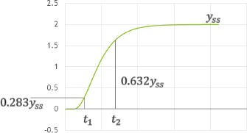

**Figure 4.8: The open loop response of plant**

𝑟𝑚 = 2 (𝑡2 − 𝑡1)

𝑡𝑑 = 𝑡2 – 𝑟𝑚

**4.4.4 Ziegler-Nichols Closed - Loop Tuning Method**

The Ziegler-Nichols closed-loop tuning method allows you to use the critical gain value, 𝐾𝑐𝑟, and the critical period of oscillation, 𝑃𝑐𝑟, to calculate 𝐾𝑝 . It is a simple method of tuning PID controllers and can be refined to give better approximations of the controller. You can obtain the controller constants 𝐾𝑝, 𝑇𝑖, and 𝑇𝑑 in a system with feedback. The Ziegler-Nichols closed-loop tuning method is limited to tuning processes that cannot run in an open-loop environment.

Determining the ultimate gain value, 𝐾𝑐𝑟. is accomplished by finding the value of the proportional- only gain that causes the control loop to oscillate indefinitely at steady state. This means that the gains from the I and D controller are set to zero so that the influence of P can be determined. It tests the robustness of the 𝐾𝑝 value so that it is optimized for the controller. Another important value associated with this proportional-only control tuning method is the critical period (𝑃𝑐𝑟). The ultimate period is the time required to complete one full oscillation while the system is at steady state. These two parameters, 𝐾𝑐𝑟 and 𝑃𝑐𝑟, are used to find the loop-tuning constants of the controller (P, PI, or PID). To find the values of these parameters, and to calculate the tuning constants, use the following procedure:

**The Tuning Procedure:**

1. Remove integral and derivative action. Set integral time (𝑇𝑖) to ∞ or its largest value and set the derivative controller (𝑇𝑑) to zero.
2. Create a small disturbance in the loop by changing the set point. Adjust the proportional, increasing and/or decreasing, the gain until the oscillations have constant amplitude.
3. Record the gain value (𝐾𝑐𝑟) and period of oscillation (𝑃𝑐𝑟).
4. Plug these values into the Ziegler-Nichols closed loop equations and determine the necessary settings for the controller.

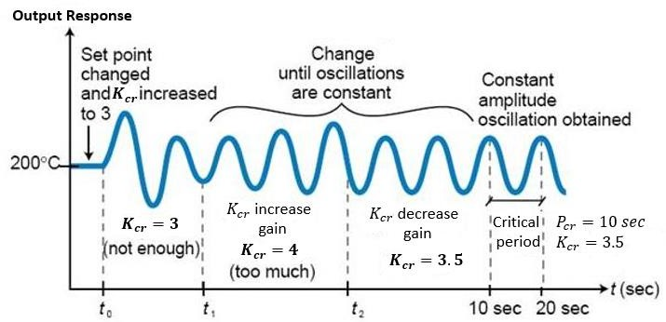

**Figure 4.9: System tuned using the Ziegler-Nichols closed-loop tuning method**

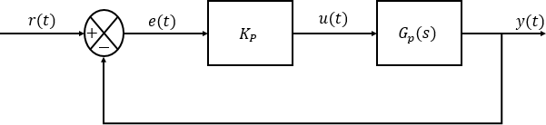**Figure 4.10: The Control system with Gain 𝐾𝑝**

The PID controller tuned by this method gives (according to the formula shown in Table)Thus, the PID Controllers adds a pole at origin and double zeros at 𝑠

If the system has a known mathematical model (Transfer function is given), then RL method can be used to find *K cr* value (critical gain) and the frequency of the sustained oscillations *w cr* . After that *Pcr* is found from

As the name suggests, this article is going to give a precise idea about the structure and working of the PID controller. However, going into details, let us get an introduction about PID controllers. PID controllers are found in a wide range of applications for industrial process control. Approximately 95% of the closed-loop operations of the [industrial automation](https://www.elprocus.com/an-overview-on-industrial-automation/) sector use PID controllers. PID stands for Proportional-Integral-Derivative. These three controllers are combined in such a way that it produces a control signal. As a feedback controller, it delivers the control output at desired levels. Before microprocessors were invented, PID control was implemented by the analog electronic components. But today all PID controllers are processed by the microprocessors. [Programmable logic controllers](https://www.elprocus.com/understanding-a-programming-logic-controller/) also have the inbuilt PID controller instructions. Due to the flexibility and reliability of the PID controllers, these are traditionally used in process control applications. Not support certain types of plant models, such as unstable plants, high-order plants, or plants with little or no time delay.

**An automated PID tuning workflow involves:**

* Identifying plant model from input-output test data
* Automatically tuning PID controller gains and fine-tune your design interactively
* Tuning multiple controllers in batch mode
* Tuning single-input single-output PID controllers as well as multiloop PID controller architectures

These values can be found from the crossing points of the root locus branches with the *jw* axis. This method doesn’t apply if the root locus doesn’t cross the *jw* axis.

* **Advantages Ziegler-Nichols Closed-Loop Tuning Methods**
  + 1. Easy experiment; only need to change the P controller
    2. Includes dynamics of whole process, which gives a more accurate picture of how the system is behaving
* **Disadvantages Ziegler-Nichols Closed-Loop Tuning Methods**

1. Experiment can be time consuming
2. Can venture into unstable regions while testing the P controller, which could cause the system to become out of control

**4.5 PID Controller Type**

The PID Tuner can tune up to seven types of controllers. To select the controller type, use one of these methods:

Provide the type argument to the launch command PID Tuner. In PID Tuner, use the Type menu to change controller types.

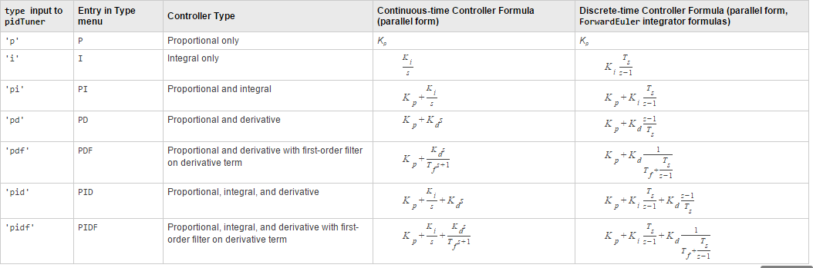

Interactive, Noninteractive, and Parallel algorithms. Some controller manufacturers allow you to choose between different controller algorithms as a configuration option in the controller software.

1. **CONTROLLER-STATCOM**

It is possible to calculate the minimum capacitance required to meet the STATCOM (or SSC) is a shunt-connected reactive-power compensation device that is capable of generating and or absorbing reactive power and in which the output can be varied to control the specific parameters of an electric power system.

It is in general a solid-state switching converter capable of generating or absorbing independently controllable real and reactive power at its output terminals when it is fed from an energy source or energy-storage device at its input terminals.

Specifically, the STATCOM considered in this chapter is a voltage-source converter that, from a given input of dc voltage, produces a set of 3-phase ac-output voltages, each in phase with and coupled to the corresponding ac system voltage through a relatively small reactance (which is provided by either an interface reactor or the leakage inductance of a coupling transformer). The dc voltage is provided by an energy-storage capacitor.

# STATCOM is defined by IEEE as a self-commutated switching power converter supplied from an appropriate electric energy source and operated to produce a set of adjustable multiphase voltage, which may be coupled to an AC power system for the purpose of exchanging independently controllable real and reactive power.**5.1 STATCOM**

Static synchronous compensator (SATCOM), or it is also known as a static synchronous generator can be operated as static VAR compensator connected in parallel, whose capacitive and inductive output currents can control which are not dependent of a system voltage (AC)

**Figure 5.1 STATCOM single line diagram**

Figure.5.2 indicates that simple operating principle of STATCOM which is connected in shunt to the power line through the magnetic circuit. In general, STATCOM’s are operated with power electronics devices. From the figure Iq and Es be the STATCOM current and voltage, Idc, Vdc are the capacitor current and voltages. And Et be the utility terminal voltage. If Es>Et it supplies reactive power and Es<Et it absorbs reactive power.

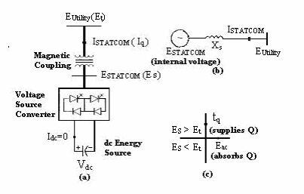

**Figure 5.2 simple operating principle**

**Table:5.1 system parameter**

|  |  |
| --- | --- |
| Ki (integrator gain constant) | 0.09 |
| Ksg (governor gain constant) | 100 |
| Kt (turbine gain constant) | 1 |
| Kps (generator gain constant) | 1 |
| R(speed regulator constant) | 3 |
| B(biasing coefficient) | 0.425 |
| ΔPd (percentage change in load) | 1% |
| Tsg (governor time constant) | 0.4 |
| Tt (turbine time constant) | 0.5 |
| Tps (generator time constant) | 20 |
| T12, T21 (synchronizing coefficient) | 1 |

**5.1.1 Typical Applications of STATCOM: -**1) Effective voltage regulation and control.2) Reduction of temporary over voltages.3) Improvement of steady-state power transfer capacity.4) Improvement of transient stability margin.5) Damping of power system oscillations.

**5.2 STATCOM: -** The STATCOM (or SSC) is a shunt-connected reactive-power compensation device that is capableof generating and or absorbing reactive power and in which the output can be varied to control the specific parameters of an electric power system. It is in general a solid-state switching converter capable of generating or absorbing independently controllable real and reactive power at its output terminals when it is fed from an energy source or energy-storage device at its input terminals. Specifically, the STATCOM considered in this chapter is a voltage-source converter that, from a given input of dc voltage, produces a set of 3-phase ac-output voltages, each in phase with and coupled to the corresponding ac system voltage through a relatively small reactance (which is provided by either an interface reactor or the leakage inductance of a coupling transformer). The dc voltage is provided by an energy-storage capacitor. STATCOM is defined by IEEE as a self-commutated switching power converter supplied from an appropriate electric energy source and operated to produce a set of adjustable multiphase voltage, which may be coupled to an AC power system for the purpose of exchanging independently controllable real and reactive power.**5.3 Typical Applications of STATCOM: -**1) Effective voltage regulation and control.2) Reduction of temporary over voltages.3) Improvement of steady-state power transfer capacity.4) Improvement of transient stability margin.5) Damping of power system oscillations.

**5.3.1 Applications of FACTS under Dynamic state: -** One of the most important capabilities expected of FACTS applications is to be able to reduce the impact of the primary disturbance. The impact reduction for contingencies can be achieved through dynamic voltage support (STATCOM), dynamic flow control (TCSC) or both with the use of UPFC. **The typical applications in dynamic state include:**

1) Damping of sub synchronous power system oscillations.2) Flicker control.3) Power quality improvement.4) Distribution system applications.**Applications of FACTS under Dynamic state: -** One of the most important capabilities expected of FACTS applications is to be able to reduce the impact of the primary disturbance. The impact reduction for contingencies can be achieved through dynamic voltage support (STATCOM), dynamic flow control (TCSC) or both with the use of UPFC. **The typical applications in dynamic state include:**1.Transient stability enhancement2.Oscillation damping3.Voltage stability enhancement4.SSR elimination.

**5.4 Static Synchronous Compensator (STATCOM)5.4.1 Introduction: -** STATCOM is a controlled reactive-power source. It provides the desired reactive-power generation and absorption entirely by means of electronic processing of the voltage and current waveform voltage-source converter (VSC).

* A single-line STATCOM power circuit is shown in Fig. 3.1, where a VSC is connected- to a utility bus through magnetic coupling. In Fig, a STATCOM is seen as an adjustable voltage source behind a reactance—meaning that capacitor banks and shunt reactors are not needed for reactive power generation and absorption, thereby giving a STATCOM a compact design, or small footprint, as well as low noise and low magnetic impact. The exchange of reactive power between the converter and the ac system can be controlled by varying the amplitude of the 3-phase output voltage, Es, of the converter
* That is, if the amplitude of the output voltage is increased above that of the utility bus voltage, then current flows through the reactance from the converter to the ac system and the converter generates capacitive-reactive power for the ac system. If the amplitude of the output voltage is decreased below the utility bus voltage, then the current flows from the ac system to the converter and the converter absorbs inductive-reactive power from the ac system.
* If the output voltage equals the ac system voltage, the reactive-power exchange becomes zero, in which case the STATCOM is said to be in a floating state. Adjusting the phase shift between the converter-output voltage and the ac system voltage can similarly control real-power exchange between the converter and the ac system.
* In other words, the converter can supply real power to the ac system from its dc energy storage if the converter-output voltage is made to lead the ac-system voltage. On the other hand, it can absorb real power from the ac system for the dc system if its voltage lags behind the ac-system voltage.
* A STATCOM provides the desired reactive power by exchanging the instantaneous reactive power among the phases of the ac system. The mechanism by which the converter internally generates and or absorbs the reactive power can be understood by considering the relationship between the output and input powers of the converter. The converter switches connect the dc-input circuit directly to the ac-output circuit. Thus, the net instantaneous power at the ac output terminals must always be equal to the net instantaneous power at the dc- input terminals (neglecting losses).
* Assume that the converter is operated to supply reactive-output power. In this case, the real power provided by the dc source as input to the converter must be zero. Furthermore, because the reactive power at zero frequency (dc) is by definition zero, the dc source supplies no reactive power as input to the converter and thus clearly plays no part in the generation of reactive-output power by the converter.
* In other words, the converter simply interconnects the three output terminals so that the reactive output currents can flow freely among them. If the terminals of the ac system are regarded in this context, the converter establishes a circulating reactive-power exchange among the phases.
* However, the real power that the converter exchanges at its ac terminals with the ac system must, of course, be supplied to or absorbed from its dc terminals by the dc capacitor.
* Although reactive power is generated internally by the action of converter switches, a dc capacitor must still be connected across the input terminals of the converter. The primary needs the amplitude of the output voltage is increased above that of the utility bus voltage, then current flows through the reactance from the converter to the ac system and the converter generates capacitive-reactive power for the ac system. If the amplitude of the output voltage is decreased below the utility bus voltage, then the current flows from the ac system to the converter and the converter absorbs inductive-reactive power from the ac system.
* If the output voltage equals the ac system voltage, the reactive-power exchange becomes zero, in which case the STATCOM is said to be in a floating state. Adjusting the phase shift between the converter-output voltage and the ac system voltage can similarly control real-power exchange between the converter and the ac system.
* In other words, the converter can supply real power to the ac system from its dc energy storage if the converter-output voltage is made to lead the ac-system voltage. On the other hand, it can absorb real power from the ac system for the dc system if its voltage lags behind the ac-system voltage.
* A STATCOM provides the desired reactive power by exchanging the instantaneous reactive power among the phases of the ac system. The mechanism by which the converter internally generates and absorbs the reactive power can be understood by considering the relationship between the output and input powers of the converter. The converter switches connect the dc-input circuit directly to the ac-output circuit. Thus, the net instantaneous power at the ac output terminals must always be equal to the net instantaneous power at the dc- input terminals (neglecting losses).
* Assume that the converter is operated to supply reactive-output power. In this case, the real power provided by the dc source as input to the converter must be zero. Furthermore, because the reactive power at zero frequency (dc) is by definition zero, the dc source supplies no reactive power as input to the converter and thus clearly plays no part in the generation of reactive-output power by the converter.
* In other words, the converter simply interconnects the three output terminals so that the reactive output currents can flow freely among them. If the terminals of the ac system are regarded in this context, the converter establishes a circulating reactive-power exchange among the phases. However, the real power that the converter exchanges at its ac terminals with the ac system must, of course, be supplied to or absorbed from its dc terminals by the dc capacitor. Although reactive power is generated internally by the action of converter switches, a dc capacitor must still be connected across the input terminals of the converter. The primary need for the capacitor is to provide a circulating-current path as well as a voltage source. The magnitude of the capacitor is chosen so that the dc voltage across its terminals remains fairly constant to prevent it from contributing to the ripples in the dc current. The VSC-output voltage is in the form of a staircase wave into which smooth sinusoidal current from the ac system is drawn, resulting in slight fluctuations in the output power of the converter.
* However, to not violate the instantaneous power-equality constraint at its input and output terminals, the converter must draw a fluctuating current from its dc source. Depending on the converter system requirements, such as ripple limits on the dc voltage and the rated-reactive power support needed by the ac system.
* The VSC has the same rated-current capability when it operates with the capacitive- or inductive reactive current. Therefore, a VSC having a certain MVA rating gives the STATCOM twice the dynamic range in MVAR (this also contributes to a compact design).
* A dc capacitor bank is used to support (stabilize) the controlled dc voltage needed for the operation of the VSC. The reactive power of a STATCOM is produced by means of power-electronic equipment of the voltage-source-converter type. The VSC may be a 2- level or 3-level type, depending on the required output power and voltage [2], [3]. A number of VSCs are combined in a multi-pulse connection to form the STATCOM. In the steady state, the VSCs operate with fundamental-frequency switching to minimize converter losses.
* However, during transient conditions caused by line faults, a pulse width–modulated (PWM) mode is used to prevent the fault current from entering the VSCs [2], [3]. In this way, the STATCOM is able to withstand transients on the AC side without blocking. capacitor is to provide a circulating-current path as well as a voltage source. The magnitude of the capacitor is chosen so that the dc voltage across its terminals remains fairly constant to prevent it from contributing to the ripples in the dc current. The VSC-output voltage is in the form of a staircase wave into which smooth sinusoidal current from the ac system is drawn, resulting in slight fluctuations in the output power of the converter.
* However, to not violate the instantaneous power-equality constraint at its input and output terminals, the converter must draw a fluctuating current from its dc source. Depending on the converter configuration employed, it is possible to calculate the minimum capacitance required to meet the system requirements, such as ripple limits on the dc voltage and the rated-reactive power support needed by the ac system.
* The VSC has the same rated-current capability when it operates with the capacitive- or inductive reactive current. Therefore, a VSC having a certain MVA rating gives the STATCOM twice the dynamic range in MVAR (this also contributes to a compact design).
* A dc capacitor bank is used to support (stabilize) the controlled dc voltage needed for the operation of the VSC. The reactive power of a STATCOM is produced by means of power-electronic equipment of the voltage-source-converter type. The VSC may be a 2- level or 3-level type, depending on the required output power and voltage [2], [3].
* A number of VSCs are combined in a multi-pulse connection to form the STATCOM. In the steady state, the VSCs operate with fundamental -frequency switching to minimize converter losses.
* However, during transient conditions caused by line faults, a pulse width–modulated (PWM) mode is used to prevent the fault current from entering the VSCs [2], [3]. In this way, the STATCOM is able to withstand transients on the AC side without blocking.
* A typical V-I characteristic of a STATCOM is depicted in Fig. 3.2. As can be seen, the STATCOM can supply both the capacitive and the inductive compensation and is able to independently control its output current over the rated maximum capacitive or inductive range irrespective of the amount of ac-system voltage.
* That is, the STATCOM can provide full capacitive-reactive power at any system voltage even as low as 0.15 pu. The characteristic of a STATCOM reveals strength of this technology: that it is capable of yielding the full output of capacitive generation almost independently of the system
* voltage (constant-current output at lower voltages). This capability is particularly useful for situations in which the STATCOM is needed to support the system voltage during and after faults where voltage collapse would otherwise be a limiting factor.

**5.4.2 The V-I Characteristic: -**

* A typical V-I characteristic of a STATCOM is depicted in Fig. As can be seen, the STATCOM can supply both the capacitive and the inductive compensation and is able to independently control its output current over the rated maximum capacitive or inductive range irrespective of the amount of ac-system voltage.
* That is, the STATCOM can provide full capacitive-reactive power at any system voltage—even as low as 0.15 pu. The characteristic of a STATCOM reveals strength of this technology: that it is capable of yielding the full output of capacitive generation almost independently of the system
* Voltage (constant-current output at lower voltages). This capability is particularly useful for situations in which the STATCOM is needed to support the system voltage during and after faults where voltage collapse would otherwise be a limiting factor.
* Figure shown below also illustrates that the STATCOM has an increased transient rating in both the capacitive and the inductive-operating regions. The maximum attainable transient overcurrent in the capacitive region is determined by the maximum current turn-off capability of the converter switches.
* In the inductive region, the converter switches are naturally commutated; therefore, the transient current rating of the STATCOM is limited by the maximum allowable junction temperature of the converter switches. In practice, the semiconductor switches of the converter are not lossless, so the energy stored in the dc capacitor is eventually used to meet the internal losses of the converter, and the dc capacitor voltage diminishes.
* However, when the STATCOM is used for reactive-power generation, the converter itself can keep the capacitor charged to the required voltage level. This task is accomplished by making the output voltages of the converter lag behind the ac-system voltages by a small angle (usually in the 0.18–0.28 range).
* In this way, the converter absorbs a small amount of real power from the ac system to meet its internal losses and keep the capacitor voltage at the desired level. The same mechanism can be used to increase or decrease the capacitor voltage and thus, the amplitude of the converter-output voltage to control the var generation or absorption.
* The reactive- and real-power exchange between the STATCOM and the ac system can be controlled independently of each other. Any combination of real power generation or absorption with var generation or absorption is achievable if the STATCOM is equipped with an energy-storage device of suitable capacity, as depicted in Fig With this capability, extremely effective control strategies for the modulation of reactive- and real-output power can be devised to improve the transient- and dynamic-system-stability limits.

**5.4.3 Multi pulse Converter Configuration: -**

* Multi-pulse operation is achieved, by connecting identical three-phase bridges, Fig. 3.4, to transformers which have outputs that are phase-displaced with respect to one another. Star and delta-connected windings have a relative 30 phase shift and a 6-pulse converter bridge
* connected to each transformer will give an overall 12-pulse operation eliminating 5th and 7th harmonics. This principle can be extended to 24- and 48-pulse operation summing at the primary windings the transformed outputs of several 6-pulse converters (4 for 24-pulse and 8 for 48-pulse operation).
* The harmonic cancellation is carried out into the transformer secondary windings. The basic issue in structuring a high-power, multi-pulse converter is the complexity of the magnetic structure that is needed. the converter operation is carried out applying low frequency (usually line frequency) firing pulse to the power switches. Due to the low switching frequency, only about one third of the converter losses are due to the switching losses, the remaining two thirds are due to the magnetic interface (conduction losses). A typical multi-pulse waveform is depicted in Fig.

**Multi pulse Converter Configuration: -**

* Multi-pulse operation is achieved, by connecting identical three-phase bridges, Fig. 3.4, to transformers which have outputs that are phase-displaced with respect to one another.
* Star and delta-connected windings have a relative 30 phase shift and a 6-pulse converter bridge connected to each transformer will give an overall 12-pulse operation eliminating 5th and 7th harmonics. This principle can be extended to 24- and 48-pulse operation summing at the primary windings the transformed outputs of several 6-pulse converters (4 for 24-pulse and 8 for 48-pulse operation).
* The harmonic cancellation is carried out into the transformer secondary windings. The basic issue in structuring a high-power, multi-pulse converter is the complexity of the magnetic structure that is needed.
* The converter operation is carried out applying low frequency (usually line frequency) firing pulse to the power switches. Due to the low switching frequency, only about one third of the converter losses are due to the switching losses, the remaining two thirds are due to the magnetic interface (conduction losses). A typical multi-pulse waveform is depicted in Fig

**5.4 STATCOM Control System: -** The control system task is to increase or decrease the capacitor DC voltage, so that the generated AC voltage has the correct amplitude for the required reactive power. The control system must also keep the AC generated voltage in phase with the system voltage at the STATCOM connection bus to generate or absorb reactive power only (except for small active power required by transformer and inverter losses).

**5.4.1 STATCOM Control System: -**

* The control system task is to increase or decrease the capacitor DC voltage, so that the generated AC voltage has the correct amplitude for the required reactive power. The control system must also keep the AC generated voltage in phase with the system voltage at the STATCOM connection bus to generate or absorb reactive power only (except for small active power required by transformer and inverter losses). PLL (phase locked loop) synchronizes GTO pulses to the system voltage and provides a reference angle to the measurement system.
* Measurement System computes the positive-sequence components of the STATCOM voltage and current, using phase-to-dq transformation and a running-window averaging. Voltage regulation is performed by two PI regulators: from the measured voltage Vmeas and the reference voltage Vref, the Voltage Regulator block (outer loop) computes the reactive current reference Iqref used by the Current Regulator block (inner loop). The output of the current regulator is the α angle which is the phase shift of the inverter voltage with respect to the system voltage. This angle stays very close to zero except during short periods of time, as explained below.
* A voltage droop is incorporated in the voltage regulation to obtain a V-I characteristics with a slope (0.03 pu/100 MVA in this case). Therefore, when the STATCOM operating point changes from fully capacitive (+100 Mvar) to fully inductive (-100 Mvar) the SVC voltage varies between 1-0.03=0.97 pu and 1+0.03=1.03 pu. Firing Pulses Generator generates pulses for the four inverters from the PLL output (ω.t) and the current regulator output (α angle). Let us suppose that the system voltage V means becomes lower than the reference voltage V ref. The voltage regulator will then ask for a higher reactive current output (positive Iq= capacitive current). To generate more capacitive reactive power, the current regulator will then increase α phase lag of inverter voltage with respect to system voltage, so that an active power will temporarily flow from AC system to capacitors, thus increasing DC voltage and consequently generating a higher AC voltage.
* As explained in the preceding section, the conduction angle σ of the 3-level inverters has been fixed to 172.5°. This conduction angle minimizes 23rd and 25th harmonics of voltage generated by the square wave inverters. Also, to reduce non characteristic harmonics, the positive and negative voltages of the DC bus are forced to stay equal by the DC Balance Regulator module. This is performed by applying a slight offset on the conduction angles σ for the positive and negative half-cycles. The control system uses the following modules:
* PLL (phase locked loop) synchronizes GTO pulses to the system voltage and provides a reference angle to the measurement system.
* Measurement System computes the positive-sequence components of the STATCOM voltage and current, using phase-to-dq transformation and a running-window averaging. Voltage regulation is performed by two PI regulators: from the measured voltage V means and the reference voltage Vref, the Voltage Regulator block (outer loop) computes the reactive current reference Iqref used by the Current Regulator block (inner loop). The output of the current regulator is the α angle which is the phase shift of the inverter voltage with respect to the system voltage. This angle stays very close to zero except during short periods of time, as explained below.
* A voltage drop is incorporated in the voltage regulation to obtain a V-I characteristics with a slope (0.03 pu/100 MVA in this case). Therefore, when the STATCOM operating point changes from fully capacitive (+100 Mvar) to fully inductive (-100 Mvar) the SVC voltage varies between 1-0.03=0.97 pu and 1+0.03=1.03 pu. Firing Pulses Generator generates pulses for the four inverters from the PLL output (ω.t) and the current regulator output (α angle).
* Let us suppose that the system voltage V means becomes lower than the reference voltage Vref. The voltage regulator will then ask for a higher reactive current output (positive Iq= capacitive current). To generate more capacitive reactive power, the current regulator will then increase α phase lag of inverter voltage with respect to system voltage, so that an active power will temporarily flow from AC system to capacitors, thus increasing DC voltage and consequently generating a higher AC voltage.
* As explained in the preceding section, the conduction angle σ of the 3-level inverters has been fixed to 172.5°. This conduction angle minimizes 23rd and 25th harmonics of voltage generated by the square wave inverters. Also, to reduce non characteristic harmonics, the positive and negative voltages of the DC bus are forced to stay equal by the DC Balance Regulator module. This is performed by applying a slight offset on the conduction angles σ for the positive and negative half-cycles.

**5.4.2 Steady State & Dynamic performance of STATCOM**

* STATCOM is in Voltage regulation mode with a reference voltage of 1.0 pu. Waveforms Illustrating STATCOM Dynamic Response to System Voltage Steps: -Initially the programmable voltage source is set at 1.0491 pu, resulting in a 1.0 pu voltage at bus B1
* When the STATCOM is out of service. As the reference voltage Vref is set to 1.0 pu, the STATCOM is initially floating (zero current). The DC voltage is 19.3 kV. At t=0.1s, voltage is suddenly decreased by 4.5% (0.955 pu of nominal voltage). The STATCOM reacts by generating reactive power (Q=+70 Mvar) to keep voltage at 0.979 pu. The 95% settling time is approximately 47 ms. At this point the DC voltage has increased to 20.4 kV.
* Then, at t=0.2 s the source voltage is increased to1.045 pu of its nominal value. The STATCOM reacts by changing its operating point from capacitive to inductive to keep voltage at 1.021 pu. At this point the STATCOM absorbs 72 Mvar and the DC voltage has been lowered to 18.2 kV. Observe on the first trace showing the STATCOM primary voltage and current that the current is changing from capacitive to inductive in approximately one cycle.
* Finally, at t=0.3 s the source voltage in set back to its nominal value and the STATCOM operating point comes back to zero Mvar.
* The figure below zooms on two cycles during steady-state operation when the STATCOM is capacitive and when it is inductive. Waveforms show primary and secondary voltage (phase A) as well as primary current flowing into the STATCOM. Steady State & Dynamic performance of STATCOM
* STATCOM is in Voltage regulation mode with a reference voltage of 1.0 pu. Waveforms Illustrating STATCOM Dynamic Response to System Voltage Steps: -Initially the programmable voltage source is set at 1.0491 pu, resulting in a 1.0 pu voltage at bus B1
* When the STATCOM is out of service. As the reference voltage V ref is set to 1.0 pu, the STATCOM is initially floating (zero current). The DC voltage is 19.3 kV. At t=0.1s, voltage is suddenly decreased by 4.5% (0.955 pu of nominal voltage). The STATCOM reacts by generating reactive power (Q=+70 Mvar) to keep voltage at 0.979 pu. The 95% settling time is approximately 47 ms. At this point the DC voltage has increased to 20.4 kV.
* Then, at t=0.2 s the source voltage is increased to1.045 pu of its nominal value. The STATCOM reacts by changing its operating point from capacitive to inductive to keep voltage at 1.021 pu. At this point the STATCOM absorbs 72 Mvar and the DC voltage has been lowered to 18.2 kV. Observe on the first trace showing the STATCOM primary voltage and current that the current is changing from capacitive to inductive in approximately one cycle.
* Finally, at t=0.3 s the source voltage in set back to its nominal value and the STATCOM operating point comes back to zero Mvar.
* The figure below zooms on two cycles during steady-state operation when the STATCOM is capacitive and when it is inductive. Waveforms show primary and secondary voltage (phase A) as well as primary current flowing into the STATCOM.
* Here it is observed that when STATCOM is operating in capacitive mode (Q=+70 Mvar), the 48-pulse secondary voltage (in pu) generated by inverters is higher than the primary voltage (in pu) and in phase with primary voltage. Current is leading voltage by 90°; the STATCOM is therefore generating reactive power. On the contrary, when the STATCOM is operating in inductive mode, secondary voltage is lower than primary voltage. Current is lagging voltage by 90°; the STATCOM is therefore absorbing reactive power.
* Finally, if you look inside the Signals and Scopes subsystem you will have access to other control signals. Notice the transient changes on α angle when the DC voltage is increased or decreased to vary reactive power. The steady-state value of α (0.5 degrees) is the phase shift required to maintain a small active power flow compensating transformer and converter losses.

1. **SIMULATION RESULTS**

**6.1 Two area load frequency control without controller**

Simulation block diagram of two area load frequency control, designed in simulation using Figure.3 and run the simulation in MATLAB with the help of parameters provided in table.1.and the simulation gives the results for change in frequency and tie line power with the change in load. Figure.6 indicates the two-area load frequency control without any controller with the 10 % change(increase) in load in area.1 shows the effect not only on the frequency of area.1 but also it shows the impact on area.2 frequency and tie line power. there is some instability in both transient and steady state frequency response of area 1,2 and tie line power Ptie 1,2. Figure.7 shows the tie-line power having a greater number of oscillations due to sudden change in load

**Figure 6.1. Two area load frequency without controller**

**Figure 6.2. Tie-line power without controller**

**6.2 Two-area load frequency control with integral controller**

The main application of controller with integral controller is to bettering the steady – state response. In integral controller as Ki value increases the magnitude also increases and due to pole at origin which makes steady state error equals to zero. Figure.8 indicates two- area interconnected system frequency response. system whose steady state error makes to zero even with sudden increase in load to 10% and Figure.9 shows the tie-line power of interconnected system whose oscillations can be reduced about its final equilibrium point.

**Figure 6.3 Two area load frequency control with integral controller**

**Figure 6.4 Two - area load frequency control, tie line power with integral controller**

**6.3 Two-area load frequency control with STATCOM controller**

Integral controller only improves the steady state response but it doesn’t show any effect on the transient response. and the STATCOM is used to improves both the transient response and inject the reactive power and absorbs so that it reduces the power oscillation damping’s of the tie-line power with sudden change in load. Figure.11 shows the two-area load frequency control with STATCOM reduce both steady state error to zero and Figure.12 shows two-area load frequency control tie line power with STATCOM which reduce the both steady state and transient oscillations tie-line power.

**Figure 6.5 Two area load frequency control with STATCOM controller**

**Figure 6.6 Two - area load frequency control, tie line power with STATCOM**

**CONCLUSION**

In this paper, two area load frequency control was modelled using MATLAB simulation for controlling area load frequency and tie line power which changes due to sudden change(increase) in load. Integral controller is used to improve the steady state response which makes steady state error is equals to zero and to improves the damping oscillations in tie line power the best controllers are FACTS devices. STATCOM is one of the basic FACTS devices which is connected in series to the tie line to make the steady state error to zero and reduce the tie line power oscillation in transient state.

**REFERENCES**

1. Kundur P.: ”Power stability and control”, Mcgraw Hill, 2009
2. Concordia, C., & Kirchmayer, L. K. (1954). Tie-Line Power and Frequency Control of Electric Power Systems - Part II [includes discussion]. Transactions of the American Institute of Electrical Engineers. Part III: Power Apparatus and Systems, 73(2), 133–146.
3. Kirchmayer, L.K: Economic control of interconnected systems. (1960). Journal of the Franklin Institute, 269(6), 492–493.
4. Jaleeli, N., VanSlyck, L. S., Ewart, D. N., Fink, L. H., & Hoffmann, A. G. (1992). Understanding automatic generation control. IEEE Transactions on Power Systems, 7(3), 1106–1122.
5. Das, D., Kothari, M. L., Kothari, D. P., & Nanda, J. (1991). Variable structure control strategy to automatic generation control of interconnected reheat thermal system. IEE Proceedings D Control Theory and Applications, 138(6), 579.
6. Chan, W.-C., & Hsu, Y.-Y. (1981). Automatic generation control of interconnected power systems using variable-structure controllers. IEE Proceedings C Generation, Transmission and Distribution, 128(5), 269.
7. Pal, B. C., Coonick, A. H., & Macdonald, D. C. (n.d.). Robust damping controller design in power systems with superconducting magnetic energy storage devices. 2000 IEEE Power Engineering Society Winter Meeting. Conference Proceedings (Cat. No.00CH37077).
8. Abraham, R. J., Das, D., & Patra, A. (2007). Effect of TCPS on oscillations in tie-power and area frequencies in an interconnected hydrothermal power system. IET Generation, Transmission & Distribution, 1(4), 632.
9. Bikash Pal and Balarko Chaudhuri. Robust Control in Power Systems. (2005). Power Electronics and Power Systems.
10. Hingorani,N.G and Gyugi,L.:”Understanding FACTS” (IEEE Press,2000)
11. Pal,B.C, Rehantz,C. and Zhang, X.P:”Flexible AC Transmission Systems: Modelling and Control”,(Springer,2006)
12. Kimbark, E.W:”Improvement of System stability by switched series capacitors”,IEEE Trans. Power Apparatus Syst. 1966,PAS-85,(2), pp.180-188
13. Rajaraman et al, Computing the damping of sub-synchronous oscillations due to a TCSC, IEEE Trans on Power Del,Vol.11,No.2,April 1996.
14. Jonas Persson, Lennart Soder:”Validity of a linear Model of a thyristor-controlled series capacitor for Dynamic Simulations”, in Proc.14th Power Systems Computation Conference, June 24th - 28th,2002,Sevilla,Spain.
15. P. Mattavelli,G.C Verghese,A.M Stankovic,”Phasor dynamics of Thyristor Controlled Series Capacitor Systems”,IEEE Summer Meeting 532-2 PWRS,1996.
16. H.A.Othman, L.Angquist, et al.,:”Analytical Modeling of Thyristor- Controlled Series Capacitors for SSR studies”,IEEE Trans. Power Systems,Vol.11,No.1,1996,pp.119-127.
17. John J Paserba,Nicholas W.Miller et al,”A thyristor Controlled Series Compensation Model for Power System Stability Analysis”,IEEE Trans.Power Delivery,Vol.10,No.3,1995,pp.1471-1478.
18. Saadat,H.:”Power System Analysis”, McGraw Hill,USA,1999.
19. Ibraheem, Prabhat Kumar and D. P. Kothari “Recent Philosophies of Automatic Generation Control Strategies in Power Systems”, IEEE Trans. on Power System, Vol. 20, No.1, pp. 346-357, Feb 2005.
20. K. C. Divya and P. S. N. Rao, “A Simulation Model for AGC Studies of Hydro-Hydro Systems” Electrical Power and Energy Systems 27, pp.335-342, 2005
21. R.J. Abraham, D.Das and A.Patra: “AGC study of a Hydrothermal system with SMES and TCPS”, European Transactions on Elecrical Power, Vol.19, pp.487-498, April 2009.
22. IEEE Committee Report: ‘Dynamic models for steam and hydro turbines in power system studies’, IEEE Trans. Power Appar. Syst., 1973, 92, (6), pp. 1904– 1915.
23. N. Cohn, Control of Generation and Power Flow on Interconnected Systems, New York, John Wiley,1986.